Document Log
Version Number | Date | Comments
0.1 | 10 September 2008 | Initial draft for discussion at GO-ESSP Security Meeting 16 September 2008
0.2 | 24 October 2008 | Revised to reflect meeting outcomes:  - Details of attributes required from IdPs.  - Deployment and Component UML diagrams adapted from meeting whiteboard photo.

Contents
1 Document Log 1
2 Contents 1
3 Purpose of this Document 1
4 Terminology 2
5 References 2
6 Profiles 2
7 Authentication / SSO 3
8 Authorization 3
9 Attribute Management 3
9.1 Attribute Assignment Policy 3
9.1.1 The ESG Attribute Service 3
9.2 Attribute Release Policy 4
9.3 Attribute Retrieval 5
9.4 Binding of attributes to Resources 5
10 Trust 5
11 Deployment Overview 6
12 Component Diagrams 7
12.1 Browser Based Authentication 7
12.2 Browser Based Authorization 8
13 Technologies 8

Purpose of this Document
Representatives from ESG and NERC DataGrid have held discussions via e-mail and telecon over the past few months to agree a security architecture to enable third party organisations to participate in the ESG federation to facilitate IPCC AR5 data access.

This document is intended as a summary of what has been agreed to date. This meeting includes the results of the security meeting held on the 16 September 2008 ahead of the GO-ESSP Meeting in Seattle.

Terminology
Where possible the terms related to ESG are used.

IdP | Identity Provider
OP | OpenID Provider – equivalent in OpenID terms to an IdP
SP | Service Provider or data provider an ESG Gateway
RP | Relying Party – equivalent to a Service Provider
Gateway | An ESG Portal which may run a number of different services
Data Node | ESG component serving data
AS | ESG Attribute Service
SSO | Single Sign On
RPS | Resource Policy Service equivalent to a Policy Decision Point (PDP)
PDP | Policy Decision Point – component which makes access control decisions based on the attributes controlling access to a resource and the attributes associated with a user requesting that resource
PEP | Policy Enforcement Point – component which enforces access control decisions. It refers back to a PDP to make an access control decision
SoA | Source of Authority – an organization which has responsibility over a given dataset or number of datasets and determines which users can register to access them

References
- GO-ESSP Security Meeting Notes and Actions, version 1.0, October 2008, [http://proj.badc.rl.ac.uk/ndg/browser/TI12-security/trunk/documentation/esgInteroperabilityForIPCCar5/GO-ESSPSecurityMeetingNotesAndActions.doc?format=raw]

- SSO for non-web applications:
  - Presentation: http://www-unix.mcs.anl.gov/~ranantha/esg/ESG-PKI-SSO.ppt
  - Reference and demo: http://www-unix.mcs.anl.gov/~ranantha/esg/PKISSO.html

- Web SSO

  - Shibboleth Evaluation: http://www.ci.uchicago.edu/wiki/bin/view/FranksProjects/ShibbolethEvalESG
  - OpenID Evaluation: http://www.ci.uchicago.edu/wiki/bin/view/FranksProjects/OpenIDEvalESG
  - Other OpenID resources: http://www.ci.uchicago.edu/wiki/bin/view/FranksProjects/OpenIdSecurity
  - OpenID Prototype Demo: http://www.ci.uchicago.edu/wiki/bin/view/FranksProjects/OpenIDDemoESG
- Architectural Assumptions v0.3, BN Lawrence, 29 May 2008

Profiles
The architecture encompasses browser and rich client based profiles.
- Browser based profile – user interacts with ESG services via a web browser
- Rich client profile – user interacts with ESG via some other client application

Discussions for IPCC AR5 interoperability have to date focussed on the browser based profile. This document focuses on this profile.

Authentication / SSO
Browser based authentication is via OpenID with caveats for increased security:
- IdPs are whitelisted by Service Providers i.e. Service Providers keep a list of IdPs that they trust. Likewise IdPs maintain a list of Service Providers that they trust.
- Connections between IdP and Service Providers are over SSL with client authentication.

Authorization
- ESG uses RBAC (Role Based Access Control)
- Resources to be secured have attributes associated with them determining access
- Users have attributes associated with them determining what resources they can access
- Access control decisions are handled by ESG Resource Policy Service (Policy Decision Point). There may be any number of RPSs deployed securing different resources at different Service Providers.
- Data is deployed at different ESG Data Nodes. Data Nodes (a PEP at a Data Node) refer access control decisions to the RPS responsible for the given dataset.

Attribute Management

Attribute Assignment Policy
- IdPs may assign attributes to their users which are specific to their organization. Some, all or none of these attributes may be passed over the OpenID interface during Single Sign On. Attributes are passed using the OpenID Attribute Exchange Extension.
- Fully participant ESG IdPs are expected to assign three basic attributes to users: Firstname, Lastname, E-mail address. These are made available to requesting ESG Gateway’s. See the ESG Attribute Service and Attribute Release Policy sections.
- An ESG participating organization may be responsible for the registration of users to access a given dataset. For example PCMDI is responsible for IPCC data access. For convenience such an organization is referred to as a Source of Authority (SoA) from here on:
  - The attributes that an SoA can assign to users governs access to a number of resources or datasets which the SoA has responsibility for.
  - The attributes have federation wide scope
  - Any number of data providers may host data protected by the attributes but they may not necessarily have control over user attribute assignment.
  - An SoA assigns attributes to users via an ESG Attribute Service.
- An ESG user is someone who can authenticate at one of the ESG trusted IdPs
- In summary, IdPs and Attribute Services can assign attributes to users.

The ESG Attribute Service
- Attribute Assignment for the purpose of data access is handled by an ESG Attribute Service. This may:
  - register an ESG user for access to a particular dataset by storing a profile of the user containing their ID together with the attribute name which governs access to that resource
  - be queried to see what attributes a given user is registered for
- For point 1a):
  - An original proposal was that an IdP would host a service which an Attribute Service may invoke to update a user’s profile held at the IdP with the new attributes that the user has registered for or equally, to withdraw attributes if the user is no longer entitled to them. This has been dropped.
- For point 1b):
  - A RPS (or PDP) can query an Attribute Service to get all the attribute information it needs about a user in order to make an access control decision
  - This means that ESG participating IdPs do not necessarily need to provide any attributes to Service Providers in order for the latter to make access control decisions: this information may be retrieved from an associated Attribute Service. This is separate from the requirement for IdPs to provide basic attributes to Gateways at initial signin. See point 6 and sections 9.2 and 9.3.
- A SoA hosts an Attribute Service. An organization which has responsibility for a dataset or group of datasets.
- Attribute Services are associated with the resources they protect: they may have users registered with them from a number of different IdPs from within the ESG federation.
- An Attribute Service may also be deployed in association with an IdP. Following the GO-ESSP Security Meeting (16 Sept) it was agreed that IdPs may also deploy Attribute Services in order to pass basic attributes back to a requesting ESG Gateway (aka. Service Provider). This additional provision is made for IdPs in the case where they are unable to configure their OpenID Provider to return these attributes to a Gateway. This could for example be the case where an ESG participating group is part of a wider organization and as such relies on the provision of an OpenID Provider from a centralised service outside their supervision. They would have no means to configure the OpenID Provider to return the required ESG specific attributes.
- A resource or dataset may be protected by more than one attribute.
- The attributes controlling access to a resource may be under the authority of different Attribute Services.
- Users will be able to register for access to a given dataset via an online form. This will interface with a corresponding Attribute Service.
- The form may include fields in order for the user to provide additional information required by the SoA
- The form will also include a Conditions of Use agreement which the user must sign up to by clicking on tick box or some other appropriate means.
- Data protection legislation needs to be taken into account in terms of what user information is taken, how it is to be used and how the agreement is worded so that the user is adequately informed e.g. for UK Data Protection Legislation and other? …
- The Attribute Service will use SAML for message interchange between itself and a client.

Attribute Release Policy
- Service Providers and Attribute Services may require attributes from IdPs:
  - For Service Providers they may need attributes to make access control decisions
  - The ESG Gateway requires basic attributes for initialization of user interfaces following sign in. See Attribute Retrieval (9.3) and ESG Attribute Service (9.1.1) sections below.
  - Attribute Services may require a minimum set of attributes in order to register a user for access to a dataset.
- An IdP determines what attributes are returned to a requesting service over the OpenID interface
- The user is informed of which attributes are required by the requesting service and is prompted to accept or reject the request. If they reject, then it may result in them being denied access to a given resource.

Attribute Retrieval
User attributes are required at two points: at initial sign in to a Gateway and for access control decisions. Special provision is made in the case of the former – see below:
- Access to user attributes are required to make an access control decision
- The ESG Gateway software also requires the release of basic attributes from an IdP in order to initialize Gateway services and the User Interface following user sign in. These attributes are:
  - Firstname
  - Lastname
  - E-mail address
- It is expected that IdPs in the ESG federation will be able to provide these attributes over their OpenID interface. However, provision is made for these exceptions:
  - Some organizations may be unable or unwilling to configure their OpenID Provider to release these attributes. In this case, they may deploy an ESG Attribute Service which can be queried by an ESG Gateway should the attributes not be available following OpenID sign in.
  - It is expected that ESG will at a later phase in development (beginning of 2009 at the very earliest) support sign in from OpenID Providers who do not support the release of the ESG required attributes and do not host an Attribute Service (e.g. Yahoo OpenID Provider service). The ESG Gateway architecture will need to be modified for this scenario The User Interface would need to be initialised without provision of these attributes or perhaps by querying an Attribute Service local to the Gateway.
- An ESG Resource Policy Service (aka PDP) may have access to attributes from two sources:
  - Attributes – if any - passed back over the OpenID interface to an ESG Gateway’s user session.
  - By querying the Attribute Service(s) associated with a resource to see if the user making the request has the required attribute(s) to gain access.

Binding of attributes to Resources
- Where secured resources are hosted a binding between the resource and the attributes that control access to it will be kept locally. e.g. a database or other repository. The Resource Policy Service provides an interface to this mapping.
- A link between attributes and the Attribute Services responsible for them will also be maintained locally. The RPS may provide this function.
- A global registry may be implemented to provide information about the mapping between attributes and Attribute Service endpoints. This supplements the information held locally by resource providers.

Trust
- Organizations participating in the ESG federation trust the authentication assertions of other ESG IdPs (OpenID Providers)
- They may also trust attribute assertions returned from an IdP during OpenID Single Sign On / from an IdP Attribute Service if deployed.
- Data providers trust attribute assertions from Attribute Services in the ESG federation.

Deployment Overview
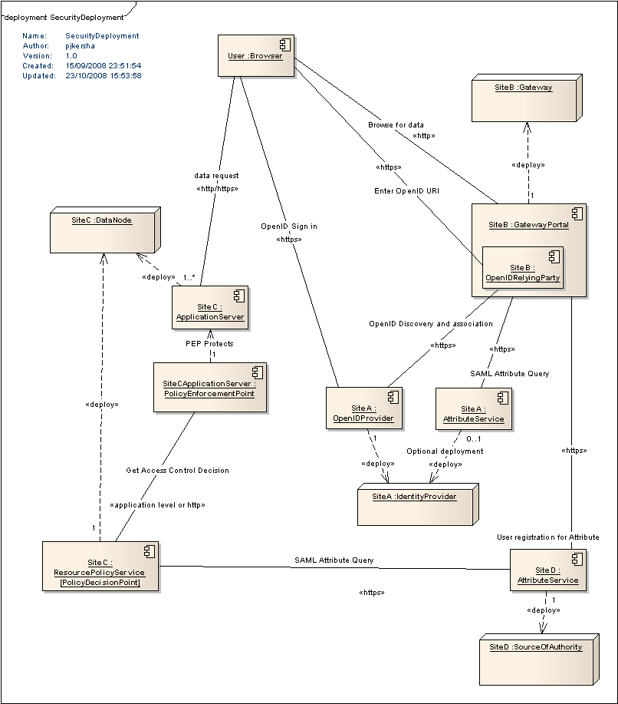

Four different sites are involved: SiteA, SiteB, SiteC and SiteD.

- SiteA is an Identity Provider participating in the ESG federation. This organization may not deploy a full Gateway or data nodes but wishes to enable its users to access data through the ESG.

- SiteB is an ESG member organisation such as NCAR who have a Gateway deployed.

- SiteC is making data available via an ESG Data Node. It has some data exposed through an application server such as THREDDS with a PEP to protect access. The PEP refers access control decisions to the RPS

- SiteD has some responsibility over the data that the user wishes to access It could for example be PCMDI. The Attribute Service associated, registers users for AR5 access and responds to queries from RPSs (SiteC’s RPS in the above) to see if a given user has AR5 access rights.

- The user is registered with an account at SiteA and browses the SiteB Gateway for data. The required data is available at the SiteC Data Node.

Component Diagrams

Browser Based Authentication
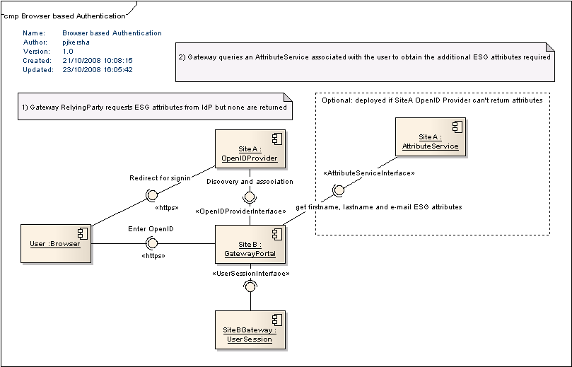
This diagram shows OpenID based Single Sign On. The user wishes to access resources from the Gateway deployed at the Service Provider SiteB. They enter their OpenID and are redirected to their Identity Provider SiteA in order to enter their credentials.

Also shown is the optional deployment of an Attribute Service at SiteA. This is included to allow for the case where SiteA’s OpenID Provider is not configured to return the required ESG attributes firstname, lastname and e-mail address using OpenID’s Attribute Exchange Extension. In this case, the Gateway queries SiteA Attribute Service for these additional attributes. See section 9.3.

The UserSession component is shown to illustrate that the Gateway Portal has some means of caching the user’s OpenID and attributes.

Browser Based Authorization
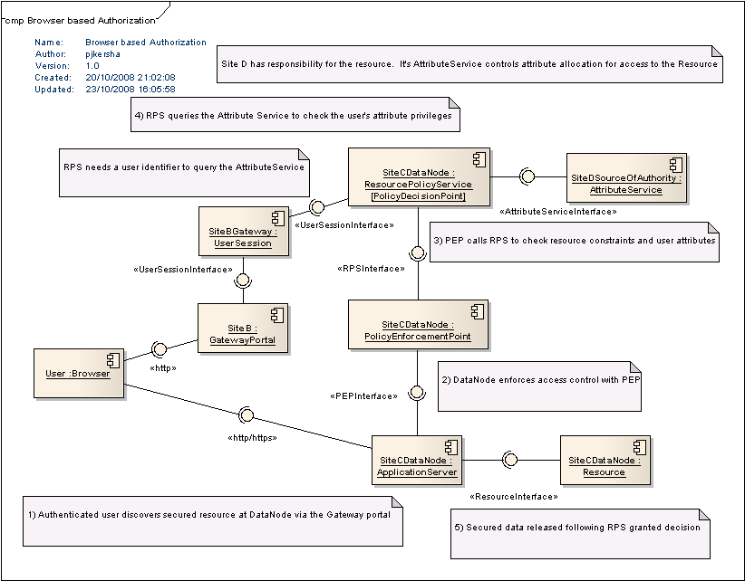

This diagram shows the components and their interfaces for browser based authorization to access a given resource available from a Data Node.

The user is already authenticated and browses the Gateway for datasets to retrieve. The Gateway directs the user to a URL for a dataset held at SiteC’s Data Node. The DataNode is running an application server such as THREDDS. Security is enforced via a callout to the PEP. The PEP refers access control decisions to the RPS. The RPS retrieves the access constraints for the given resource requested by the user. It also queries the Attribute Service associated with the attribute controlling access to the resource. The Attribute Service is hosted at SiteD which has some responsibility over access to the data. For example, PCMDI allocates AR5 user attributes.

If the RPS grants access, this response is returned to the PEP and the application server can proceed with data retrieval.

Technologies
- OpenID is the chosen framework for Single Sign On.
- Attribute Services will use SAML to exchange attribute information. SAML tokens are likely to be exchanged over a SOAP based web service interface. This would make use of SOAP in a lightweight capacity as a basic wrapper to SAML queries and assertions without the use of specifications such as WSDL. TBC
- Web services will be secured using SSL with client authentication. TBC (Alternative SAML with XML digital signature over http?)

